Batch: B2 Roll No.: 16010121200

Experiment No. 05

Grade: AA / AB / BB / BC / CC / CD /DD

Signature of the Staff In-charge with date

TITLE: Implementation of Process synchronization algorithms using semaphore -
producer consumer problem, reader-writers problem
_____________________________________________________________________

AIM: Implementation of Process synchronization algorithms using semaphore - producer consumer problem, reader-writers problem
______________________________________________________________________
Expected Outcome of Experiment:

CO 3. To understand the concepts of process synchronization and deadlock.
_____________________________________________________________________
Books/ Journals/ Websites referred:

- Silberschatz A., Galvin P., Gagne G. “Operating Systems Principles”, Willey Eight edition.
- Achyut S. Godbole , Atul Kahate “Operating Systems” McGraw Hill Third
Edition.
- William Stallings, “Operating System Internal & Design Principles”, Pearson.
- Andrew S. Tanenbaum, “Modern Operating System”, Prentice Hall.
_____________________________________________________________________
Pre Lab/ Prior Concepts:

Knowledge of Concurrency, Mutual Exclusion, Synchronization, Deadlock, Starvation.
_____________________________________________________________________

Description of the chosen process synchronization algorithm:
Producer-Consumer problem:
We have a buffer of fixed size. A producer can produce an item and can place in the buffer. A consumer can pick items and can consume them. We need to ensure that when a producer is placing an item in the buffer, then at the same time consumer should not consume any item.
In this problem, the buffer is the critical section. (Critical Section is the part of a program which tries to access shared resources. The critical section cannot be executed by more than one process at the same time.)

To solve this problem, we need a binary semaphore, mutex for mutual exclusion between processes and two counting semaphores – full and empty.
‘full’ keeps track of the number of items in the buffer at any given time and ‘empty’ keeps track of the number of unoccupied slots.

Initialization of semaphores:
mutex = 1
Full = 0
Empty = Capacity (of buffer)

Implementation details: (printout of code)
from threading import Thread
from random import random, randint
import time

# Shared Memory
buffer = []

# Semaphores
mutex = 1

def wait():
global mutex
if mutex > 0:
mutex -= 1
return False
else:
return True

def signal():
global mutex
mutex += 1
return

# Producer Thread
def Producer():
print("Producer: Running")
time.sleep(0.1)
global buffer, mutex
items_produced = 0
while items_produced < 10:
while wait():
pass
item = items_produced + 1
buffer.append(item)
items_produced += 1
print("Producer produced item:", item)
signal()
if randint(0,2):
time.sleep(randint(1,3))
print("Producer: Done")
return

# Consumer Thread
def Consumer():
print("Consumer: Running")
time.sleep(0.1)
global buffer, mutex
items_consumed = 0
while items_consumed < 10:
while wait():
pass
if len(buffer) != 0:
item = buffer[0]
del buffer[0]
items_consumed += 1
print("Consumer consumed:", item)
signal()
if randint(0,2):
time.sleep(randint(1,3))
else:
signal()
time.sleep(1)
print("Consumer: Done")
return

producerThread = Thread(target = Producer)
consumerThread = Thread(target = Consumer)

# start threads
producerThread.start()
consumerThread.start()

# wait for threads to finish
producerThread.join()
consumerThread.join()

Output:
Run #1: Run #2:
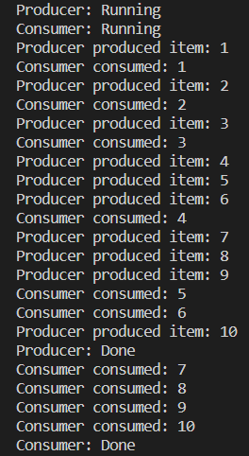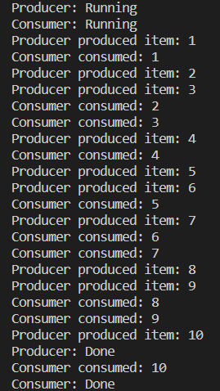
Conclusion:
Implemented the producer-consumer problem in python using semaphores.
Single producer, single consumer, unbounded buffer were used.
Understood the concepts of process synchronization, concurrency, mutual exclusion between processes and use of semaphores.
Post Lab Objective Questions

- A semaphore is a shared integer variable
  - That can’t drop below zero
  - That can’t be more than zero
  - That can’t drop below one

- Mutual exclusion can be provided by the
  - Mutex locks
  - Binary semaphores
  - Both a and b
  - None of these

- A monitor is a module that encapsulates
  - Shared data structures
  - Procedures that operate on shared data structure
  - Synchronization between concurrent procedure invocation
  - All of the above

- To enable a process to wait within the monitor
  - A condition variable must be declared as condition
  - Condition Variables must be used as Boolean objects
  - Semaphore must be used
  - All of the above

Date: 10/10/2023 Signature of faculty in-charge

